ADAPTIVE LEARNING INTELLIGENCE PLATFORM USING EDUCATIONAL DOCUMENT ANALYSIS AND PERSONALIZED LEARNING ANALYTICS
Scope and Limitations
Department of Computer Science and Engineering, TKR College of Engineering & Technology
Batch A1 (CSE-A) · Academic year [ACADEMIC YEAR]
Table 1: Project team
S.No. | Student name | Roll number
1 | A Dhanush | 23K91A0501
2 | Ale Vijayalaxmi | 23K91A0508
3 | Burri Mallikarjun | 23K91A0549
4 | Atragada Nagatrimurthulu | 23K91A0517

Project guide: Raghavendra
Chapter and section numbers quoted in the text (for example Chapter 8 or Section 6.2) refer to the full project report, 17.Final Document. Figures and tables in this document are numbered from 1.

1. SCOPE

1.1 In scope
The scope is what the delivered system does and was tested to do. Each item exists in the code base and has the evidence named in the last column.
Table 2: Features in scope
No. | Feature | Where | Evidence
1 | Registration, login, logout and a signed session cookie; users see only their own data | /api/auth/*, current_user | Security tests; cross-user test
2 | Upload of PDF, DOCX and TXT files up to 16 MB with a subject label | POST /api/documents | Upload tests; latency in Section 8.8
3 | Text extraction, cleaning, 180-word chunking, subject and unit hints, up to 12 topics | utils/text_extraction.py | 15 extraction tests; Section 8.6
4 | Per-user TF-IDF index and retrieval of the top four chunks | utils/rag_engine.py | Section 8.3
5 | Answer from the notes with sources, history of the last ten questions | POST /api/ask, GET /api/ask/history | Sections 8.4, 8.5, 8.11
6 | Five-question cloze quiz per document, server-side grading, results stored per topic | /api/quiz/* | Section 8.7; API tests
7 | Priority roadmap from quiz accuracy per topic | GET /api/roadmap | Boundary tests; screen in Section 8.2
8 | Dashboard with counts, subject-wise accuracy and recent documents | GET /api/dashboard | Screen in Section 8.2
9 | React interface, light and dark themes, responsive layout; original Flask interface | frontend/, app.py | Build and Playwright checks
10 | Optional Claude answers when ANTHROPIC_API_KEY is set | RAGEngine._llm_answer | Fall-back tested with a stub; real calls not measured

1.2 Out of scope
• Semantic (embedding) retrieval in the product. Dense retrieval was measured only as a reference experiment.
• Question classification, adaptive retrieval and learned compression of the base paper [1].
• Revision schedules and spaced repetition, knowledge tracing [17], curriculum coverage and study velocity.
• OCR of scanned documents, handwriting, images and formulas.
• Grading of free-text answers; quizzes are four-option fill-in-the-blank only.
• Teacher or administrator roles, shared classes, sharing of documents between students.
• Cloud deployment, HTTPS, e-mail and mobile applications.
• Content moderation, plagiarism checks and fairness or accessibility audits.

2. ASSUMPTIONS
The system and its evaluation rest on the following assumptions. Where an assumption is doubtful it is repeated as a limitation.
1. A student uploads documents whose text can be extracted: PDF with a text layer, DOCX paragraphs or plain text, in English.
2. The questions a student asks use words that also occur in the notes; the retriever is lexical.
3. Subject and unit headings follow the patterns "Subject:", "Course:", "Unit n:" or "Chapter n:" with an Arabic numeral.
4. One user works on one PC on localhost; the backend trusts the frontend origin http://localhost:5301.
5. A quiz term (a TF-IDF keyword of the document) is a meaningful topic of revision.
6. The evaluation corpus of Wikipedia articles is a fair stand-in for lecture notes. This is an assumption: it was not tested on real notes.
7. Medians of timings on a shared i5 PC describe the order of magnitude of a laptop deployment.

3. LIMITATIONS
Each limitation is stated with its measured consequence and with what would address it. The identifiers L1 to L13 are used in the other chapters.
Table 3: Limitations
ID | Limitation | Consequence (measured) | What would address it
L1 | Retrieval is lexical TF-IDF, not semantic | Hit@1 0.403, Hit@4 0.792; BM25 Hit@1 0.500; BM25 + dense Hit@4 0.889 | BM25 plus dense hybrid (Section 10.1)
L2 | No relevance threshold | 9 of 12 off-topic questions answered with unrelated sentences | Refuse when the top-1 score is below about 0.12 to 0.15
L3 | Extractive answer is a fixed ~90 words and favours sentences that repeat the question | Answer-key recall 0.861 in chunks, 0.667 in the answer; definitions 0.500 | Answer-aware sentence selection or an LLM compressor
L4 | SAC-RAG components (question classifier, type-specific retrieval, LLM compression) are not implemented | Objective 4 only partly met | Add a rule-based or LLM classifier and route retrieval by type
L5 | Heading detection is limited; DOCX tables and scans are not read | Roman-numeral, "Module n" and numbered headings found 0 of 5; table text lost; scans give no chunks | More heading patterns, table extraction, OCR
L6 | Two uploads with the same file name share one file on disk | Deleting one document removes the file of the other (rows stay) | Store files under unique names (document id)
L7 | Quiz questions are cloze sentences on TF-IDF terms | 17 of 30 acceptable; answer term still visible in 18.2% of questions | Sentence quality filters; blank every occurrence; better distractors
L8 | Roadmap topics are single keywords and are keyed by topic name only | Generic topics ("using", "normal"); the same keyword in two subjects is merged | Use units or noun phrases as topics; key by subject and topic
L9 | Roadmap and dashboard use quiz accuracy only | No revision schedule, coverage or study velocity (objectives 5 and 6 partly met) | Knowledge tracing [17], spaced repetition, coverage tracking
L10 | Security suited to local use only | Cookie not Secure, default secret key if .env is missing, no rate limiting or CSRF token, only the frontend origin is allowed by CORS | HTTPS, secret from the environment, rate limits, CSRF protection
L11 | State is process-local and the index is rebuilt after each upload | Index rebuild 197 ms at 672 chunks and 964 ms at 5,376; active quiz and cache lost on restart | Persist quiz state and indexes; incremental indexing
L12 | The evaluation corpus and question set are small and not from students | 95 % interval of Hit@4 0.694 to 0.875 | Collect real notes and student questions
L13 | Screenshots use scripted quiz answers | Dashboard and roadmap scores illustrate the screens only | A user study

The limitations are not equally serious. L1 to L3 affect the quality of every answer and are the first to address; L5 and L7 affect the usefulness of the knowledge repository and the quiz; L10 matters only if the application is exposed beyond a local machine.
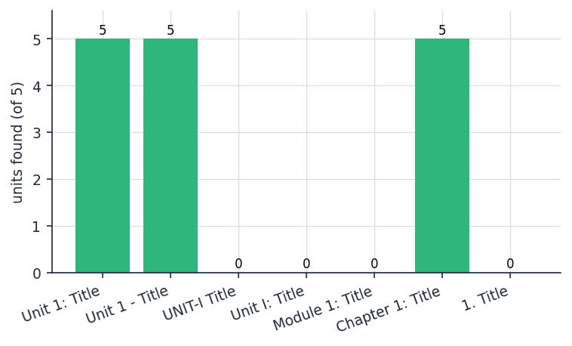
Figure 1: Measured limitation: units found by the heading detector for seven heading styles (five units each)
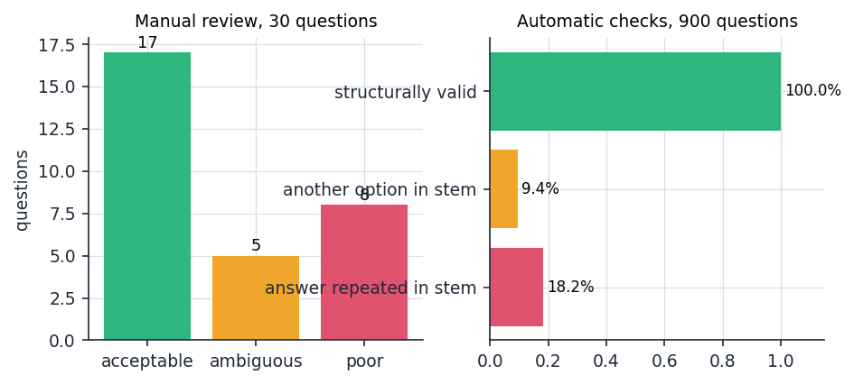
Figure 2: Measured limitation: quality of the generated quiz questions (manual review and automatic checks)

4. WHAT WAS NOT MEASURED
Some behaviours could not be measured within the project. They are listed so that no reader assumes a result that does not exist.
• The Claude answer mode. No API key was available. The code path is tested only with a stub that fails or returns a fixed string; answer quality, cost and latency of real calls are unknown.
• Concurrent users and long sessions. One simulated user was used for latency; behaviour with several users, a multi-process server or a large number of documents beyond 5,376 chunks was not measured.
• Scanned documents. The behaviour on a PDF without a text layer was tested (no text, a warning); recognition of the text by OCR does not exist and was not measured.
• Real student material. No real syllabus, lecture note or question bank was used; the corpus is Wikipedia text.
• Learning outcomes. Whether the quizzes and the roadmap improve a student's results is unknown; no user study, survey or controlled trial was made.
• Answer correctness judged by people. Answers were scored by the presence of a key string, not by human raters; exact match and F1 against reference answers were not computed.
• Accessibility. Keyboard operation and contrast were considered in the design but no audit with assistive technology was done.
• Cause of rare slow database commits. Quiz submission showed 1 to 2 second outliers in one or two of 30 calls; the cause was not isolated.

